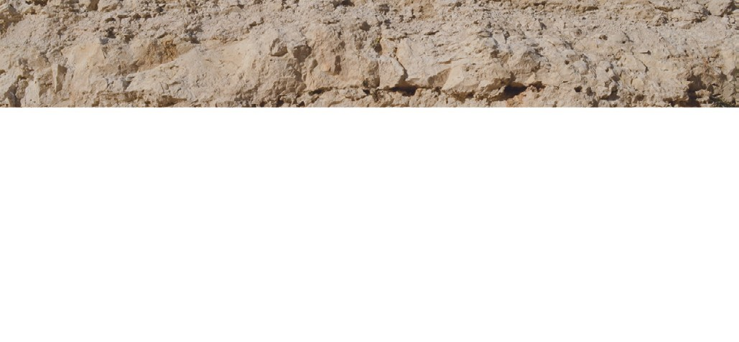
Red wine
Appellation
Ribera del Duero
Vintage 2019
Variety
100% Tempranillo (Tinto ﬁno)
Vineyard

bodegas

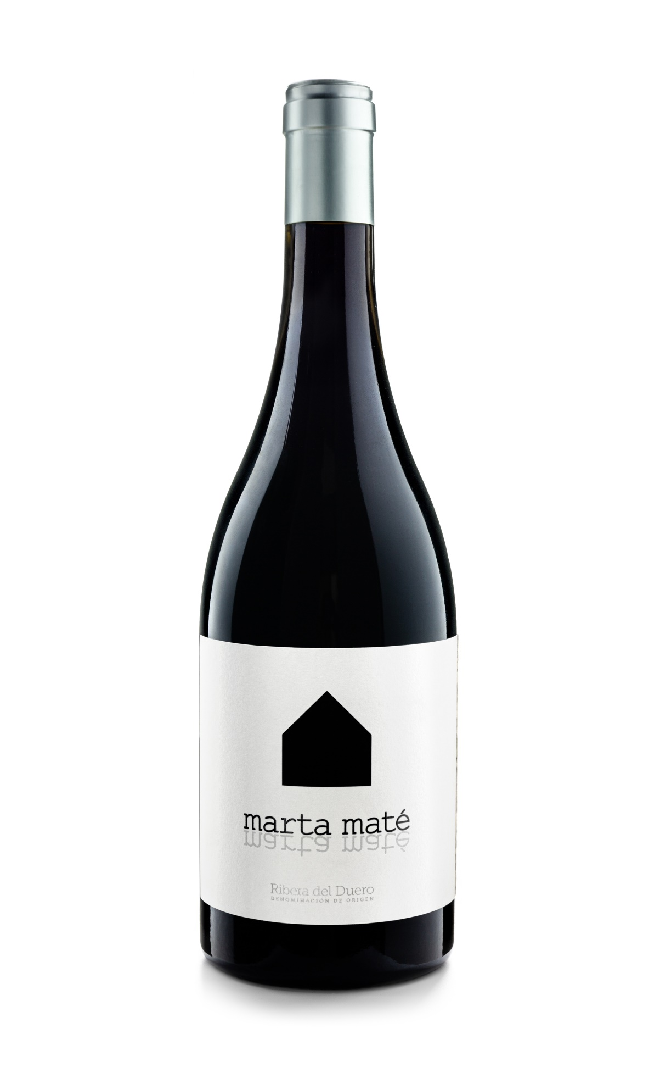
Organic vineyard over 100 years old, situated in Tubilla del Lago (a village with a latitude which is the most northern in the D.O. and an altitude of more than 900 meters) and in Gumiel del Mercado at 930 meters, where we practice according to biodynamic methods. The vineyards are located on great heights with clay and calcareous soils. (www.martamate.com/vinedo)
Minimum tillage and manual harvest into boxes.
Winemaking
The fermentation takes place in concrete tanks with indigenous yeast and 12 days of maceration.
Aging
14 months in French oak barrels and final blending in concrete vats. Every year is different based on the respect for the product.
Bottling
August 2021. Not cold stabilized.
Production
16.400 bottles of 0,75l and 300 bottles of magnum.
Alcohol
14,10% Vol.
Total Acidity
5,05 g/l

TASTING NOTES
The 2019 vintage has an Atlantic influence.
The expressive and complex nose of flowers and minerals harmonizes with the landscape it comes from.
The first sip is almost sweet with velvety sensations. A very long finish in mouth and nose reveals a good natural acidity and the vitality of the Ribera del Duero, but with its own personal identity.

PRIZES / AWARDS
Tim Atkin / 96 points Vintage 2018
Tim Atkin / 97 points Vintage 2016
Tim Atkin / 95 points Vintage 2014
Jancis Robinson 2016 (U.K.) / 17/20 Vintage 2012

Bodegas Marta Maté
Camino de Caleruega s/n
09453 Tubilla del Lago (Burgos - Spain)
Tel +34 947 613 924 / Móvil +34 629 636 506
bodega@martamate.com / www.martamate.com

